The Systems Analyst

To be able to daydream about the ‘perfect’ Systems Analyst job for me upon graduation, I would first need to get a better understanding of what a System Analyst does day to day. The two ways that I can make this assessment would be current job ads on various websites and/or real life queries from those who have worked in this position. I mean, who else better to tell me about a System Analyst than those who have actually worked in the field. After I get an understanding of the job, then I can possibly make a closer assessment of what to expect in my ideal role.
First up, and the easiest part of this paper, would be researching by websites. Using the Google search engine, I did a general search request for ‘Systems Analyst Vacancies in Connecticut and NYC’. It appeared my search was too general because I have over 90 million (yes, million…….with an M) results.
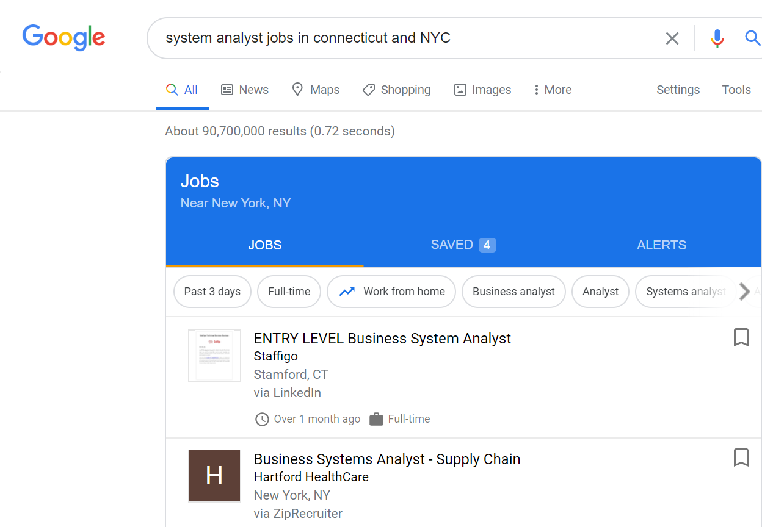
I decided to shorted my search with even more details as to get a more accurate assessment by using the following criteria:
- Full time only
- System Analysts in the title only
- NYC and Stamford, CT only, and
- Only jobs posted within the past week
In my results, I chose two: one was a entry level and one is senior level. Oracle currently has a vacancy for an entry level Systems Analyst. They list the following:
- 8 – 10 years of experience in a medium-to-large distributed network and computing environment;
- Knowledge of Microsoft Azure/Exchange Online
- Powershell
- Microsoft Activity Directory Hybrid sendmail/postfix;
- Drive Exchange integrations with existing Oracle cloud services, and;
- Oracle Cloud Infrastructure (Jobstinger, 2020).
The second position was found on INDEED. Their list of requirements was a little shorter:
- Knowledge of Salesforce and Outreach;
- Knowledge of Excel dashboards and custom reports;
- Data exports and imports;
- Create and maintain training materials;
- Salesforce Administrator Certification (Indeed, n.d.);
Both jobs seemed to require a Bachelors degree in Information Technology or Computer Science with a few years of some related experience. Both appears to have some specific certification in a related technology (i.e. Cloud services or report making). Neither specifically mention a programming language, which was my initial thought as a prerequisite. Also, both mention a softskill such as management or communication.
Another option to understand this position was to do personal interviews. I was unable to do an extensive one-on-one interview with anyone in a Systems Analyst position, but I was able to obtain a few posts from those who had worked in this capacity in the past. At ‘ZeroToProTraining’, Hasan Mir says that a Systems analyst is the following:
- Analyze and design information systems;
- Research problems and plans solutions;
- Recommends software and systems;
- Coordinates development (Mir, 2014).
There seemed to be several key words in all three references:
- Analyzing
- Designing
- Data administration;
Based on these advertisements and videos, I would presume that problem solving is the elephant in the room. One needs to be able to ascertain what is wrong through related research tools, fix the problem, and then explain the solution for future fixes, if needed. Staffing agencies like Robert Half and Staffigo Technical Services had vacancies but their prerequisites were oddly much more general. Instead of asking for a specific language or certification, they tended to focus on soft skills or business related skills in general. While I understand that the Systems Analyst is more involved than these few examples, I am not sure that a Systems Analyst is the type of position I would search for upon graduation. I envision a position where coding and design is more emphasized on both the front and back end. I like the idea of creating something beautiful (front end development) or something functional (back end development), or a combination of both. While there a simpler, non-code related ways to reach this code, possibly by adding SQL, HTML, CSS, Javascript, and some form of version control, or even WordPress (Rivera, 2018), coding fascinates my mind more than anything else.

References
Jobstinger. 02 Sep 2020. Retrieved: 06 Sep 2020, from: https://jobstinger.com/New-York/newyork/etc/vacancy-4711125.html?utm_campaign=google_jobs_apply&utm_source=google_jobs_apply&utm_medium=organic
Indeed. (n.d.). Retrieved: 06 Sep 2020, from: https://www.indeed.com/q-Systems-Analyst-l-Connecticut-jobs.html?vjk=a5dee3591a57a978
Mir, H. 05 Apr 2014. “Who Is A Systems Analyst?” Retrieved from: https://www.youtube.com/watch?v=XCx6ol18544
Rivera, J. 13 Apr 2018. “What Is A Full Stack Developer & How To Become A Full Stack Developer in 1 Year.” Retrieved from: https://www.youtube.com/watch?v=UtDpYVf9jKU

